Data Collection and Preprocessing Phase

Date | 03 November 2024
Team ID | 739763
Project Title | Age and Gender Detection using Deep Learning
Maximum Marks | 6 Marks

Data Exploration and Preprocessing Template
Identifies data sources, assesses quality issues like missing values and duplicates, and implements resolution plans to ensure accurate and reliable analysis.

Section | Description
Data Overview | Project Title: Age and Gender Detection using Deep Learning  Objective: Develop a deep learning model that accurately detects age and gender from facial images.  Data Sources: Publicly available datasets (e.g., UTKFace, Adience, FairFace, IMDB-WIKI)
Univariate Analysis | Univariate analysis is understanding the data with a single feature.
Bivariate Analysis | Bivariate analysis explores the relationship between two  variables simultaneously. It investigateshow changes in one variable correlate or interact with changes in another variable
Data Preprocessing Code Screenshots
Loading Data | 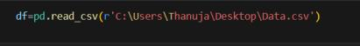

Handling Missing Data | 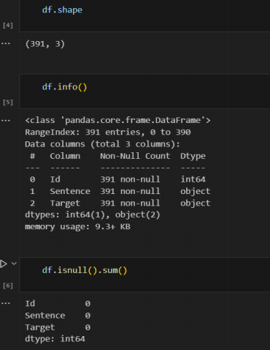
Save Processed Data | 